Tatevik Azoyan
August 8, 2024

Executive Summary

Ability to capture and save screenshots from the extension and later review them as they do review notes will allow all Haibrid users to retain more diverse sources of information in one place. By reducing the need to use other methods/apps to save screenshots, this feature improves usability of the product, increases user working efficiency, eventually enhancing Haibrid’s appeal to wider segment of users.

Feature Name | Screenshots
Product Area | Extension and main website
User Persona/ Story | All Haibrid users.  As a user, I want to be able to save images as part of my highlights in the quickest way possible.
Description | Overview  Images provide a quick way to capture and document important information. Screenshots are helpful for visual representation, record-keeping, and to communicate complex ideas quickly, removing the necessity to write down detailed descriptions.  Key Features  - “Screenshot” thumbnail in the extension  - Displaying screenshots in the source cards on the main project page
User Problem | Currently Haibrid is limited to saving text only, but a lot of people on the user calls (e.g. Cyril Aidi, Lori Youmshajekian, Johannes Ruf, Armen Fljyan, Maneh Seiranian, etc.) mentioned that they might have the need to upload images and other types of multimedia if they start using Haibrid, as the majority of tools our potential users currently use have that functionality. This is relevant for users from all segments (media, academia, etc.), as it will allow to save:  - photos  - parts from videos  - formulas, tables, etc.  - sections from PDFs when opened via browser
Value Proposition | By offering a convenient and intuitive way of capturing information, the screenshots feature aims to save time during initial documentation and recall at later stages, allows an alternative way of bookmarking for visual learners, and makes it easier to share information with other collaborators, ultimately enhancing productivity of users.
Objectives | - Enhanced user satisfaction and retention  - Testing the need in saving images (checked by user analytics), which can help us to validate if we need to develop image saving and image uploading features
Assumptions | - Users may come across images/tables/any information other than plain text while browsing that they would like to save and later recall  - Users may need to save multiple images from one source
MVP | - Clicking on the “Capture” icon from the extension and getting the ability to capture screenshots while browsing (similar to Arc easel)  - Displaying screenshots in the source cards on the main project page  - save screenshot source link
Out of Scope | - Drag and drop screenshots from source cards to editor  - Saving images from websites as highlights via right click – “Save image to Haibrid”  - Uploading images from PC from main website (in the form of a source card and/or directly to the editor)  - Attaching images from websites as highlights via right click  - Having filters in the extension to search for URLs/PDF/Image  - Showing previously taken screenshots/any other image in the extension  - Saving Screenshots while mobile browsing
KPIs
Requirements | - Users should be able to take a screenshot of any portion of the screen by clicking on a descriptive “Screenshot” icon in the extension  - Screenshot should not be editable, but users should immediately see the mini version of screenshot in the extension once an image is captured and should have the ability to delete it and/or add new screenshots by clicking on the “Screenshot” icon again  - Users should be able to save screenshots to any project/unassigned sources (the same way as for any highlight)  - Users should be able to add notes and tags while saving a screenshot (optional, the same way as for any highlight)  - Users should be able to do maximum of 5 screenshots at once (without closing the extension), <> chevrons should appear allowing to view all screenshots one at a time  - Screenshots should be shown on the main website as a separate annotation card within source cards  - If this URL is already saved, screenshot should be added as an annotation under the existing source  - If there is nothing else saved from this URL, need to save the source link and source name (same way as when saving URLs from the extension)  - No need to show previously saved images when reopening the extension, in sticky notes, and extension search
Competitor /Market Research | Arc Easel is the closest feature found that can act as an inspiration for the screenshot feature.  Majority of other products allow saving existing images that exist on the webpage or uploading images from computer, which are separate distinct features (Google Keep, Hylinker)
High-level Mock Ups |   Google keep sample of saving images through the extension  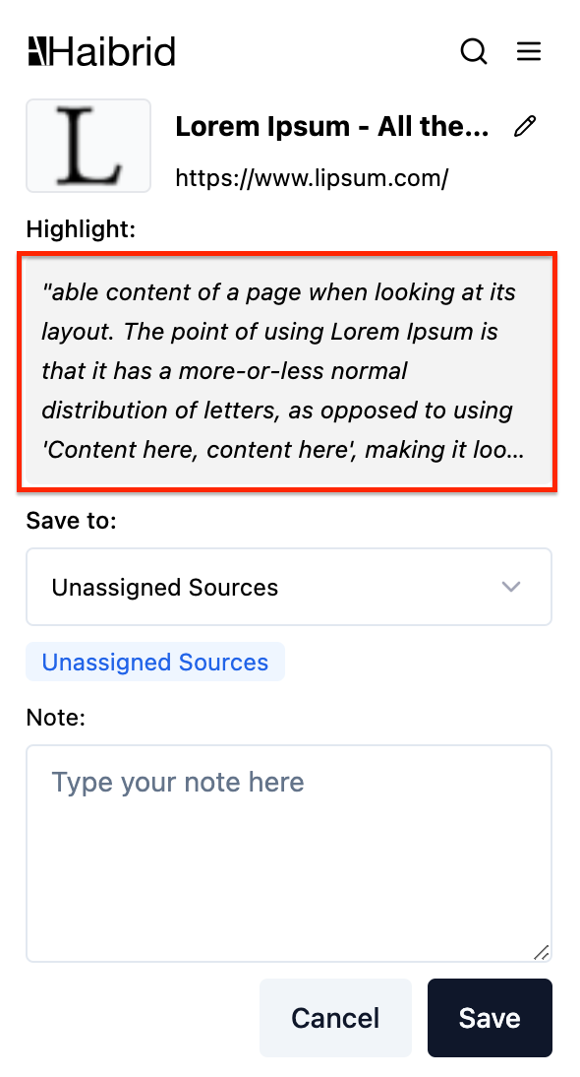  Where the image is suggested to be placed in the Haibrid extension  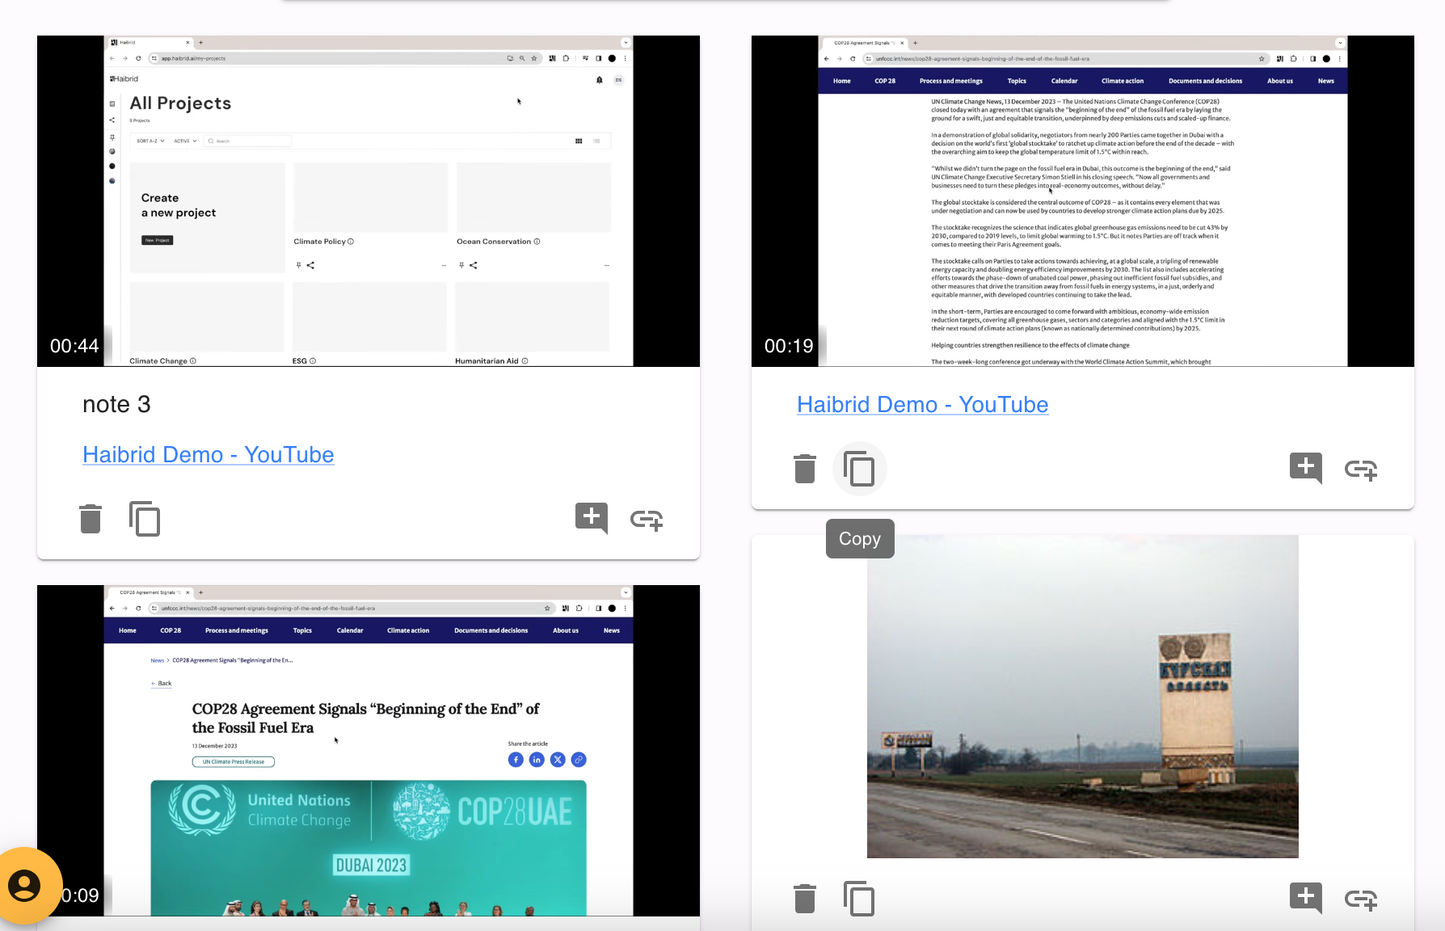  Source card UI example

Appendix: Check out https://en.eagle.cool/download for more advanced image capturing features that can be implemented later:

- Batch save all images from the website
- Capture visible (quickly taking screenshot of the part of the page that is currently visible)
- Capture page (capture whole page in form of a screenshot (with auto-scroll and auto-screenshotting)
- Uploading images by drag and drop from web
- Saving source, context, and all sorts of metadata related to screenshot

